Name: Nachiket Jagdale
Class: A3-B1
Roll no.-02

PRACTICAL NO. 6

Aim: Construction of OBST

Problem Statement: Smart Library Search Optimization
Task 1:
Scenario:
A university digital library system stores frequently accessed books using a binary search
mechanism. The library admin wants to minimize the average search time for book lookups by
arranging the book IDs optimally in a binary search tree.
Each book ID has a probability of being searched successfully and an associated probability for
unsuccessful searches (when a book ID does not exist between two keys).
Your task is to determine the minimum expected cost of searching using an Optimal Binary
Search Tree (OBST).
Input Format
First line: integer n — number of book IDs.
Second line: n integers representing the sorted book IDs (keys).
Third line: n real numbers — probabilities of successful searches (p[i]).
Fourth line: n+1 real numbers — probabilities of unsuccessful searches (q[i]).
Keys: 10 20 30 40
P[i]: 0.1 0.2 0.4 0.3
Q[i]: 0.05 0.1 0.05 0.05 0.1

Output Format
Print the minimum expected cost of the Optimal Binary Search Tree, rounded to 4 decimal places.

CODE:
#include <stdio.h>
#include <float.h>
#define MAX 100
void OptimalBST(float p[],float q[],int n,float E[MAX+1][MAX+1],float W[MAX+1][MAX+1],int R[MAX+1][MAX+1]){
int i,j,k,d;float cost;
for(i=0;i<=n;i++){E[i][i]=q[i];W[i][i]=q[i];R[i][i]=0;}
for(d=1;d<=n;d++){
for(i=0;i<=n-d;i++){
j=i+d;E[i][j]=FLT_MAX;W[i][j]=W[i][j-1]+p[j]+q[j];
for(k=i+1;k<=j;k++){
cost=E[i][k-1]+E[k][j]+W[i][j];
if(cost<E[i][j]){E[i][j]=cost;R[i][j]=k;}
}
}
}
}
int main(){
int n,i;float p[MAX],q[MAX];float E[MAX+1][MAX+1],W[MAX+1][MAX+1];int R[MAX+1][MAX+1];int keys[MAX];
printf("Enter number of book IDs: ");scanf("%d",&n);
printf("Enter sorted book IDs:\n");for(i=1;i<=n;i++)scanf("%d",&keys[i]);
printf("Enter probabilities of successful searches:\n");for(i=1;i<=n;i++)scanf("%f",&p[i]);
printf("Enter probabilities of unsuccessful searches:\n");for(i=0;i<=n;i++)scanf("%f",&q[i]);
OptimalBST(p,q,n,E,W,R);
printf("\nMinimum expected cost of OBST: %.4f\n",E[0][n]);
return 0;
}
OUTPUT:
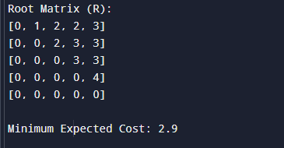

Task 2:
https://www.geeksforgeeks.org/problems/optimal-binary-search-tree2214/1

CODE:
class Solution {
static int optimalSearchTree(int keys[], int freq[], int n) {
int[][] cost = new int[n][n];
for (int i = 0; i < n; i++)
cost[i][i] = freq[i];
for (int l = 2; l <= n; l++) {
for (int i = 0; i <= n - l; i++) {
int j = i + l - 1;
cost[i][j] = Integer.MAX_VALUE;
int sum = 0;
for (int k = i; k <= j; k++)
sum += freq[k];
for (int r = i; r <= j; r++) {
int c = sum;
if (r > i) c += cost[i][r - 1];
if (r < j) c += cost[r + 1][j];
if (c < cost[i][j]) cost[i][j] = c;
}
}
}
return cost[0][n - 1];
}
}
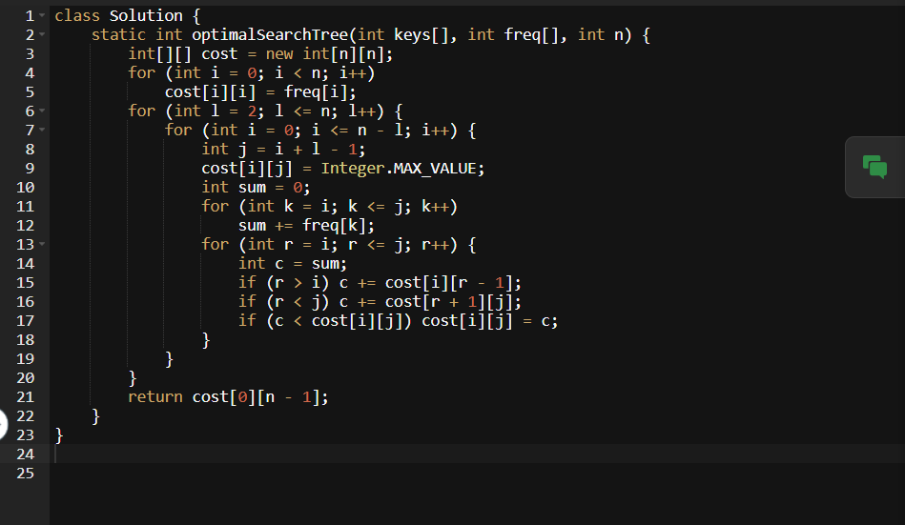
OUTPUT:
